**IAT 814 – Visualization and Visual Analytics**

**Final Project Report**

**Hospital Bed Management**

Padmanabhan Rajendrakumar (301360373)

Lakshmi Priya Kenday Sivaram (301399387)



**Motivation:**

Availability of beds in a hospital is a key measure to maximise patient care and effective cost management. One of the major problems many hospitals face today is the inefficient management of beds or the inefficient bed tracking systems that are available [1]. Hospital beds left unoccupied as a result of waiting for the staff members to service the beds and to get it ready for the next patient is a significant cost to the Health Industry [2]. The *Bed Turnaround Time (BTAT)* in question extended from the time discharge instructions were given to the patient to the time a new patient arrives [2]. Many people are involved in the process of discharging a patient and preparing the bed for the next admitted patient. However, most of the process is currently manual which involves physically checking the rooms to check the availability, assigning staff for servicing them based on the status, etc.

The proposed prototype of the dashboard is designed to improve the bed turnaround time through visualization of various measures like average turnaround time, admission and discharge rates as well as to quickly spot the bed statuses and identify beds that needs to be prioritized for cleaning. The visuals will aid the users to explore other measures like occupancy rate and waiting time impact on bed turnaround time. Hence the dashboard design will address most of the requirements of Bed Coordinators, Unit Managers and House-Keeping Supervisors through status maps and charts in managing the patient flow efficiently. It will also allow the users to interactively explore various measures and dimensions through filters and selection and will aid in locating the bottlenecks in the operation with a goal of improving the overall process.

**Goal:**

The goal of this project is therefore to optimise the Bed Turnaround process through visualization of resources (beds) in an efficient way, and to identify any trends in the dataset with regards to patient discharges and admissions. Our Visualisation dashboard will be useful both to the Bed Coordinators and the other stakeholders involved. The intended audience are listed below.

Primary: Unit Managers, Central Bed Coordinators   
Secondary: Hospital Managers, House-keeping Service Managers

We wanted our dashboard to answer some of the questions that the users will come across in their day-to-day operations of bed management and optimising house-keeping resources. Some of the questions that could be answered are:

* What’s the occupancy rate in each Units? How’s it influencing the admissions and discharges?
* What’s the Bed Turnaround rate by Unit? Where are the delays? And is there any relation to discharges?
* What’s the current status of beds in each unit? Where to deploy the house-keeping staffs and to prioritize cleaning?
* What’s the Admissions, Discharges and Transfer trends over the months? And How’s it helpful in planning the bed capacity? Is there any correlation between them and the bed turnaround time?

**Data:**

For our design, we are assuming a fictitious hospital with 5 units. And each unit has a specific number of beds. The name of the units and the number of beds in each unit that are assumed are shown below

|  |  |
| --- | --- |
| **Unit** | **Beds** |
| General – 1N | 15 |
| Surgical – 1S | 10 |
| Intensive Care Unit - 1W | 10 |
| Special Care Unit- SCU | 4 |
| Maternity - BP | 5 |

Sample *Bed Turnaround Time (BTAT)* metrics like Patient Departure time and next Patient Arrival Time were provided by Fraser health. But the data is modified to suit the hospital units and beds that’s been used for dashboard design. Other data like admissions, transfers are simulated using metrics from Canadian Institute of Health Information (CIHI) Discharge and Admission Dataset (DAD) [4]. Since getting real samples of hospital data is challenging due to confidentiality and sensitivity, we used online tool <https://mockaroo.com/> to generate data from the known metrics [16]. Some of the datasets that are simulated for the dashboard design are

* Patient log with details such as admission, Transfer details and discharge datetime. (data is generated for Feb 2019-March 2019)
* Occupancy Rate for each of the units.

Dimensions in our design

* + Unit – Name of the unit
  + BedNum – The bed number in the given unit
  + PatientID – A unique identifier given to a patient
  + AdmitDateTime – The date and time a patient was admitted
  + DischargeDateTime – The date and time a patient was discharged
  + TransferDateTime - The date and time a patient was transferred from one bed to another.

Measures in our design

* + TurnaroundTime – (DischargeDateTime - AdmitDateTime of next patient)
  + TotalOccupied – Total number of beds occupied in a unit at a given time
  + BedStatus – Current status of a bed
  + NumberofAdmissions – Number of admissions on a given date
  + NumberofDischarges – Number of discharges on a given date
  + NumberofTransfers – Number of transfers on a given date

We used Excel sheets and Tableau Prep builder to join datasets like Units and Beds with Patient Log data to create a complete dataset. Turnaround Time is calculated by calculating the difference in time between discharge and the next patient arrival time. All the data in Comma Separated files (CSV) are converted to JSON format for uploading to D3 and JavaScript files using online CSV to JSON convertor tool [10].

**Implementation**

Hospital Bed Management Dashboard is developed as a web‐application using JavaScript XML (JSX) with ReactJS [13] and visualization libraries D3.js [12] and Recharts.js[14]. By using D3.js, we are able to take advantage of the powerful visualization features of D3 for mapping bed status layout and interactive animation capabilities like Zooming and filtering on specific datasets like discharges and transfers. By using Recharts, we could design some of the bar graphs and line charts and integrate seamlessly into React components. Finally, the use of React and CSS, helped us to combine the visuals created using D3 and Recharts into individual components and build a nice looking User Interface layout.

The source code for Hospital Bed Management is available on GitHub at the following link:   <https://github.com/padmanabhan-rajendrakumar/iathospdashboard>

The prototype is accessible at: <https://iathospdashboard.netlify.app/>

*Note: If the dashboard is viewed on a small screen, the charts get wrapped around. In that case, please zoom to 90% or 80 % of the original size.*

**Visualization Design:**

The Hospital Bed Management dashboard is divided into 3 sections or panes – The left, middle and the right section. The dashboard focuses on three major things – Bed Status, Bed Turnaround Time Status and Summary and Admission/Discharges/Transfer Status and Summary. (Figure 1: Hospital Bed Management Dashboard)

The dashboard at start up gives the overview of all units first which will be helpful for Hospital Managers and Central Bed Coordinator to see statuses across the all hospital units. To see each individual units or compare between units, we have added Unit filters which will allow individual Unit Managers to concentrate on their own Unit and see statuses.

***The Left Section*** of the dashboard gives the overview of Bed occupancy rates across Units (stacked bar chart) and the bed status map of the hospital (Treemap Hospital layout). Stacked bar chart gives the number of occupied beds vs unoccupied beds by Unit. Unit filter can be used to see the numbers to specific Unit. Bed status map layout is designed using D3 TreeMap layout. With the hospital as the root node in the hierarchy, Units are designed as children. Each Unit has its own children nodes which represent the bed numbers. The TreeMap helps us quickly understand which beds are occupied and which beds need attention. Units are aligned to represent the original hospital layout, for example 1N is placed in the top North corner. The color coding of each beds indicates the occupancy status and dirty beds. Tooltips allow to browse through the status of individual beds. This will be useful to Unit clerks, Bed Coordinators to communicate with House-keeping staffs to quickly attend to services where needed.

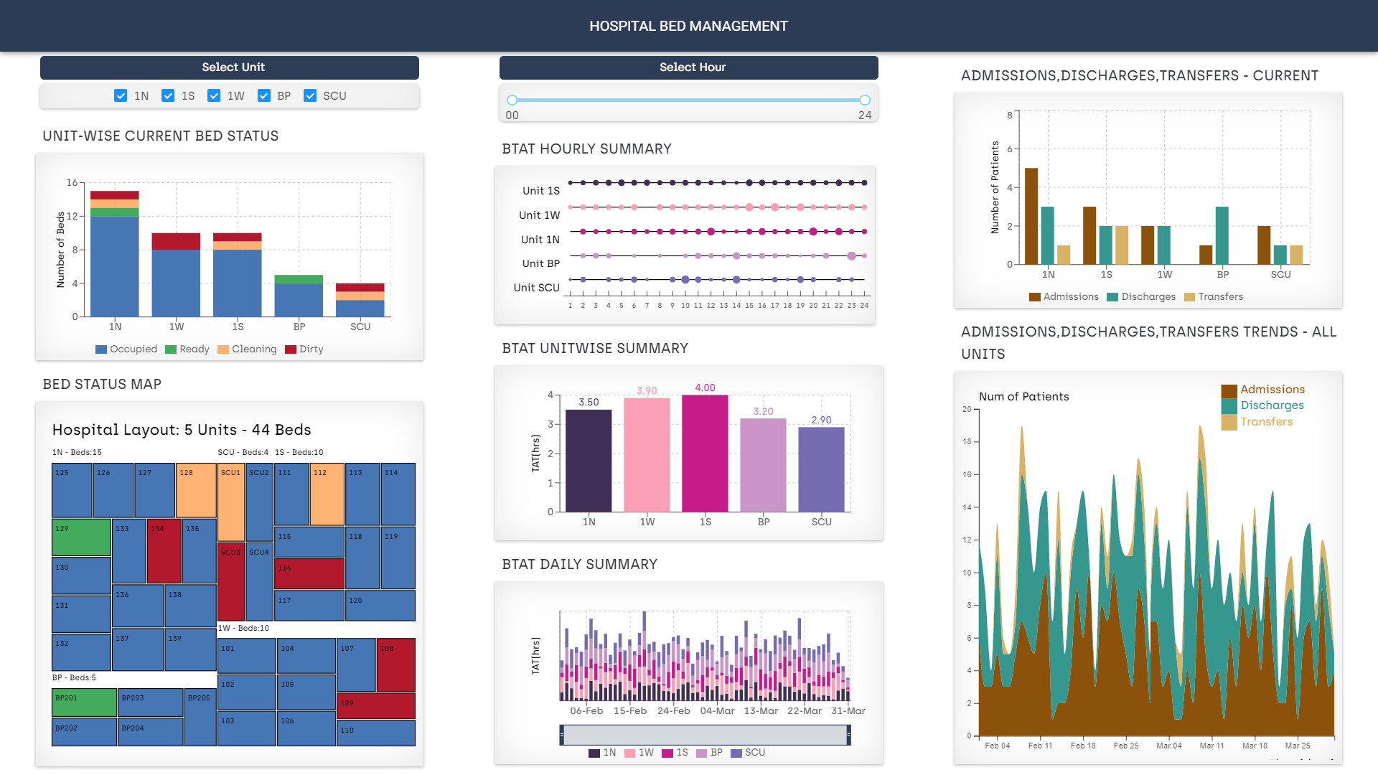

Figure 1: Hospital Bed Management Dashboard

***The Right Section*** provides the current Admissions, Discharges and Transfer (ADT) numbers by Unit (side by side bar chart) and the ADT trends seen over the past 2 months (Stacked Area chart). This chart could be compared with the Occupancy chart on the right side to answer the question related to occupancy rate and the impact on Admissions. Stacked Area chart is designed using D3 tool and allows selection of Admissions, Discharges and Transfers individually. Also, the dates could be zoomed in by rectangular selection to see patterns over a specific time period. Double clicking on the chart will revert back to its original position. Color coding on the right section indicate Admissions, Discharges and Transfers events.

***The Middle Section*** provides summary of the Bed Turnaround Time (BTAT) by hour and by day for the past few months (Feb,March) and the current BTAT across units. The BTAT hourly summary provides an overview of the bed turnaround time for every unit for all 24 hours of the day. It will help the user to understand if there are any hourly patterns that cause the turnaround time to be high. It is denoted by a multi scatter chart where the size of the bubbles denotes the duration of the turnaround time. Larger the bubble, the larger the turnaround time in that hour. This chart also has a hour slider attached to it which will help the user to look at a closer hour range instead of the entire 24-hour range. The second chart is a Stacked Bar graph that shows the daily turnaround time across all units. This chart has a brush filter attached to it which can be used to filter a specific date range (Feb,March). The third chart in this section is a simple bar chart that tells the current turnaround time across all units. The main unit filter can be used to show a specific unit on this chart.

**Design Choices:**

* Screen displays are made easy to understand with simple encodings like bars, lines and dots so that information such as statuses and alerts is quickly identifiable by non-tech staffs (users)
* All the relevant charts are rearranged and fitted to a single page layout to allow for easy comparisons and eliminate scrolling and switching between tabs.
* Bed statuses are indicated using color coding which follows traffic signal light color (Red-Dirty, Amber-Cleaning, Green-clean & Ready)
* Use of familiar charts like bar chart to represent quantity comparison.
* To show the patterns and trends over time period, line charts, area charts are used.
* Use of filters makes it easy to see the status by Units and focus on desired units.
* Brushing with dates makes it easy to concentrate on specific date range.
* Size of the (dots) in BTAT by hour chart indicate the turnaround time. Bigger the size, higher the turnaround time. This will be helpful in spotting the delay quickly and explore the reasons causing the delay.

**Interactions:** Below are **s**ome of the interactions that we have implemented.

* Filters: By Unit

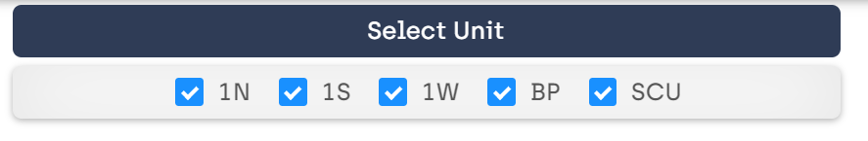

* Slider: Hour Slider (BTAT Hourly Summary)

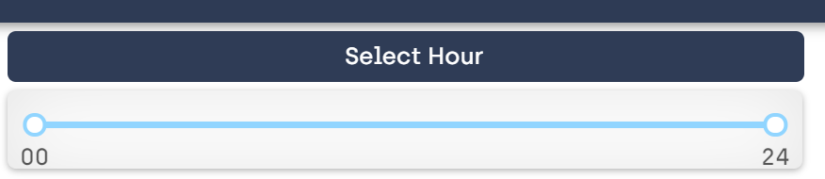

* Selection: Brushing (BTAT Daily Summary)

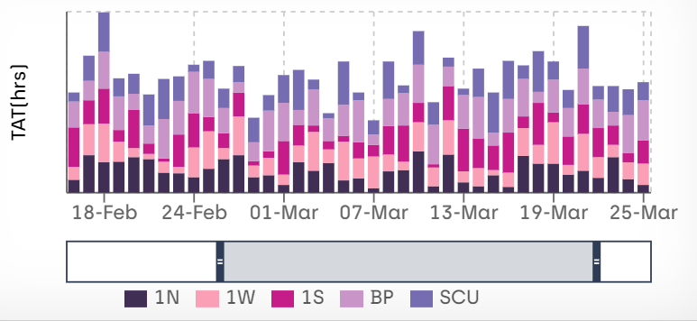

* Zomm Area (Admissions, Discharges, Transfers trend)
* Tooltips to annotate and highlight bed status and to show quantities.

**Limitations:**

* Since the data is simulated using random methods, patterns and trends might not reflect the original status, but is used to see the relative trends.
* Because of the availability of limited dataset, other explorations like impact of wait time on bed turnaround could not be implemented.

**Future Work:**

Though we could provide the interactions through filters and selection, we couldn’t provide the user with links to compare between different charts interactively. This is because of the data source being diverse and included different dimensions and unable to understand the domain requirements. Future work will involve obtaining complete dataset and working to understand the relations between dimensions required for this problem statement. Also, would like to integrate the original hospital layout as SVG file and provide the bed status in real time. This task requires detailed understanding of the technique involved and couldn’t be completed within the time frame. And finally, we also wanted the dashboard to display potential anticipated discharges and transfers status across units which will be helpful in bed capacity planning.

**Evaluation:**

Since the project aims to improve the process around bed management, evaluation will include working with the users and stakeholders involved. Schneiderman & Plaisant in their paper pointed out that evaluations of user-centered designs require a well-designed ethnographic notions of user observation, surveys, interviews and automated user logging activities [9]. Some of the identified approaches for our Dashboard design are:

**Formative Design Evaluation**

* Will include understanding the current processof bed management through closed groupmeeting with Stakeholders involved like central Bed Coordinator (Access Coordinator), Unit Managers, Nurses etc.,
* If available, analyzing the communication logsbetween units, or field observations if permitted.
* Taking samples of the metrics like bed turnaround for a period.

**Summative Protype Testing**

* Walking through the design with users and understanding user feel.
* Monitoring performance using prototype –process improvement, task completion time. (user satisfaction, ease of use)
* Comparing the data collected with the original process and using statistics to prove results.

**Conclusion:**

Our aim to provide solution to the bed management problem in the hospitals through visualization of resources and metrics involved is enabled with this dashboard design.

The Hospital Bed Management dashboard will give an overview of the bed turnaround time metrics and will let interactively explore the effects of the turnaround time on patient flow and quality of care. Our dashboard visualization will provide Unit managers, Bed coordinators in a hospital to quickly identify bed statuses and allocate resources like house-keeping staffs to appropriate locations in a timely manner. We have used established visualization idioms to design charts and interaction which will enable to see the patterns in admissions and discharges and plan for bed capacity accordingly.

The prototype could be further extended to include additional features required by the users through collaboration with stakeholders. When used with real-time data, this dashboard Visualization will also reduce the communication delays between units and will aid in improving the bed turnaround time.

**References**

1. E. C. Brown and J. Kros, “Reducing Room Turnaround Time at a Regional Hospital,” Quality Management in Health Care, vol. 19, no. 1, pp. 90–102, Mar. 2010, doi: 10.1097/QMH.0b013e3181ccbd50.
2. L. B. Chartier, L. Simoes, M. Kuipers, and B. McGovern, “Improving Emergency Department flow through optimized bed utilization,” BMJ Open Quality, vol. 5, no. 1, Sep. 2016, doi: 10.1136/bmjquality.u206156.w2532.
3. X. Chen, L. Wang, J. Ding, and N. Thomas, “Patient Flow Scheduling and Capacity Planning in a Smart Hospital Environment,” IEEE Access, vol. 4, pp. 135–148, 2016, doi: 10.1109/ACCESS.2015.2509013.
4. “Discharge Abstract Database metadata (DAD) | CIHI,” Jan. 16, 2020. https://www.cihi.ca/en/discharge-abstract-database-metadata (accessed Apr. 15, 2020).
5. “Hospital Bed Use with Tableau Prep - Tableau.” <https://help.tableau.com/current/prep/en-us/prep_tutorial_hospitalbeds.htm> (accessed Apr. 16, 2020).
6. E. Meeks, “Interactive Applications with React & D3,” Medium, Jul. 13, 2019. https://medium.com/@Elijah_Meeks/interactive-applications-with-react-d3-f76f7b3ebc71 (accessed Apr. 15, 2020).
7. “d3/d3-3.x-api-reference,” GitHub. https://github.com/d3/d3-3.x-api-reference (accessed Apr. 15, 2020).
8. B. Shneiderman, “The Eyes Have It: A Task by Data Type Taxonomy for Information Visualizations,” p. 8.
9. Shneiderman, Ben, and Catherine Plaisant. "Strategies for evaluating information visualization tools: multi-dimensional in-depth long-term case studies." Proceedings of the 2006 AVI workshop on Beyond time and errors: novel evaluation methods for information visualization. ACM, 2006.
10. “CSV to JSON - CSVJSON.” https://csvjson.com/csv2json (accessed Apr. 15, 2020).
11. sdq, “Build A Dashboard Application with React + D3,” Medium, Sep. 25, 2019. https://medium.com/shidanqing/build-a-dashboard-application-with-react-d3-6ba4f46b876b (accessed Apr. 15, 2020).
12. M. Bostock, “D3.js - Data-Driven Documents.” https://d3js.org/ (accessed Apr. 16, 2020).
13. “React – A JavaScript library for building user interfaces.” <https://reactjs.org/> (accessed Apr. 16, 2020).
14. Recharts.” https://recharts.org/en-US/ (accessed Apr. 16, 2020).
15. S. Murray, Interactive Data Visualization for the Web.
16. “Mockaroo - Random Data Generator and API Mocking Tool | JSON / CSV / SQL / Excel.” https://mockaroo.com/ (accessed Apr. 16, 2020).